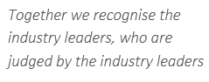
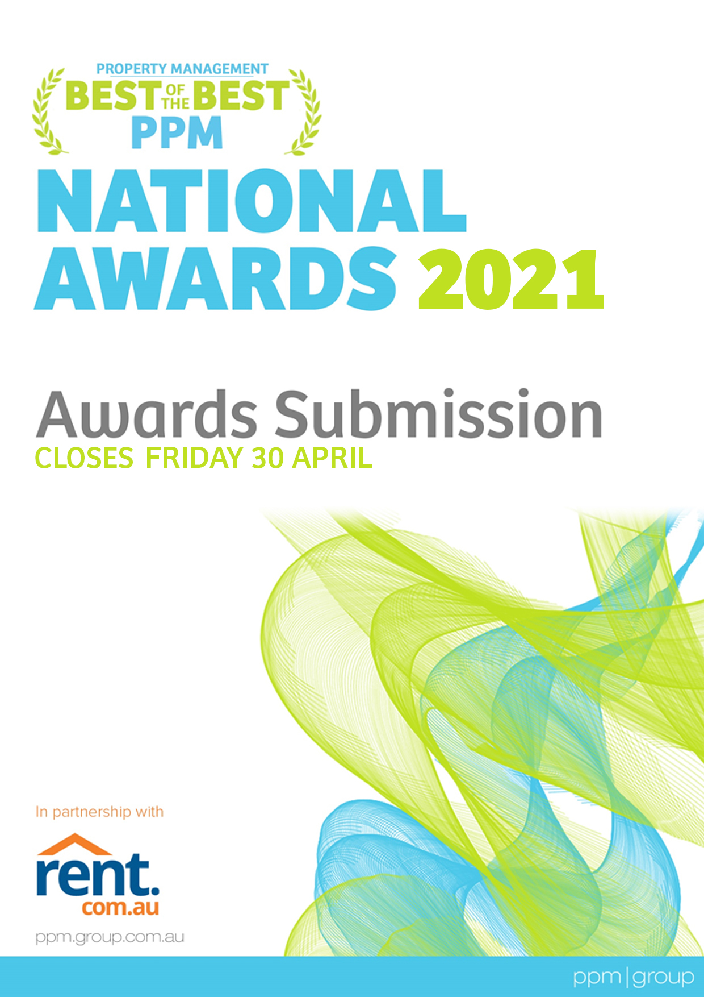
NEW LIVE STREAM FORMAT
* Within Australia
www.ppmgroup.com.au
In partnership with

PROPERTY MANAGEMENT
INDUSTRY

INTRODUCTION
OPEN TO ALL PROPERTY MANAGEMENT TEAMS AND AGENCIES ACROSS AUSTRALIA
There is no cost or fee to enter the PPM National Property Management Industry Awards.
Welcome to the 2021 PPM National Property Management Industry Awards submission.
There are two parts to this submission process that must be read and completed:
Part 1: A Submission Requirements & Awards Summary Checklist ‘The Rules’
Part 1: B Industry Leaders | The PM Influencers ‘Judging Panel’
Part 2: Submission Category Forms

IMPORTANT UPDATE

The 2021 PPM National Property Management Awards will now be held as a separate event to the PPM National Property Management Conference, which were both combined events in the past.

The Awards are open to all property management agencies and property management team members across Australia.

Due to the 2021 PPM National Property Management Conference being postponed in accordance with the advice from the QT Hotels (hosts of the event), third-party professional advice, and other stakeholders there will be a new live stream format for the Awards Presentation night.

AWARDS PRESENTATION NIGHT | LIVE STREAM BROADCAST
Awards Presentation Night Date: TO BE ADVISED
The new 2021 PPM National Property Management Awards Presentation night format will be a live stream announcement to the industry with social cell gatherings at venues and restaurants (COVID permitting) set up around Australia… managed by our industry leaders The PM Influencers, who will be judging the PPM National Property Management Industry Awards.

Together we recognise the industry leaders, who are judged by the industry leaders

PPM GROUP | CELBRATING 20 YEARS.
PPM Group is an international company that specialises in the development of property management workflow, checklist, and process systems; the delivery of training, consultancy, coaching, health checks and due diligence services, as well as an extensive range of products and learning resource tools designed to educate, motivate, and empower business owners and their property management teams to reach their full potential, improve their performance, and increase profits.
PPM Group also hosts Australia's longest running National Property Management
Industry Conference.
Wishing each property management entrant success.
DEBBIE PALMER
Founder & Managing Director PPM Group

PPM NATIONAL PROPERTY MANAGEMENT INDUSTRY AWARDS BEST OF THE BEST
Welcome to the PPM National Property Management Awards, the Best of the Best... where together we recognise the industry leaders, who are judged by the industry leaders, collectively known as The PM Influencers.

Receiving an award is one of the most sought-after career goals for all agencies and property management team members.

The PPM National Property Management Awards opened to the industry (outside of PPM members) in 2009. The focus of the awards is to recognise and encourage business excellence amongst all agencies and property management team members, who aspire to be the Best of the Best and to create a network of achievers and leaders who want to contribute positively to the future direction of the industry.

PPM Group team members will not take part in the judging process unless disclosed in writing.

Participating in any industry awards is a great process to undertake, allowing business agencies and all property management team members an opportunity to reflect and focus on their:

- Service delivery
- Internal systems implemented
- Adherence to legislation, compliance, and best industry practices
- Integration of technology
- Team culture
- Marketing initiatives
- Brand placement
- Growth
- Improvement of performance
- Goals
- Income generation and profits
- Community service involvement
- Industry involvement
- Overall achievements

The award finalists and winners gain exceptional media exposure, press releases, trophies, and award logos for marketing and promotional opportunities to enhance their brand, trust, and creditability.

AWARD CATEGORIES

Introducing our PPM National Property Management Industry Awards categories:

- Property Manager of the Year
- Business Development Manager of the Year
- Leasing Consultant of the Year
- Property Management Support Team Member of the Year
- Property Management Client Service Award of the Year (Agency)
- Property Management Agency of the Year (Small and growing – less than 400 properties)
- Property Management Agency of the Year (Larger – greater than 400 properties)
- Property Management Digital Presence of the Year (Agency)

This is a well-respected national industry awards process that attracts the Best of the Best from around the nation, who are prepared to take the time to invest and commit to showcasing their excellence in their nominated category.

PART 1A
SUBMISSION REQUIREMENTS & AWARD SUMMARY CHECKLIST
THE RULES

There is no cost or fee to enter the Awards.

All submissions must be emailed to awards@ppmgroup.com.au

IMPORTANT DATES
Award Submissions Close | Monday 14 June 2021
Awards Presentation Night | TO BE ADVISED

PART 1A SUBMISSION REQUIREMENTS
THE RULES * | Palmer Professional Management Group Pty Ltd ‘PPM'
By participating in the PPM National Property Management Industry Awards, it is agreed:
- If the ongoing uncertainty of Covid-19 does not subside, it could impact on the social cell group gatherings and the PPM National Property Management Industry Awards event as whole.
- If for any reason that the live stream broadcast is unable to take place, the event will be postponed.
- The PPM National Property Management Industry Awards are open to all Residential property management team members and agencies of Australia.
- There is no entry cost associated with the submission. However, associated costs with preparing the submission and participating in the awards presentation night may incur a cost should you wish to attend.
- Industry leaders, collectively known as The PM Influencers, will judge each award category.
- PPM will not take part in the judging process unless it is disclosed in writing.
- Judges may include current PPM | System members, property management team members, industry service providers, or Award sponsors.
- Judges and any of their associates can participate in the PPM National Property Management Industry Awards as there are multiple judges in each category, providing transparency and a fairness in the scoring process.
- Judges will assess the submissions based on the responses to questions and the Award statistics & information (where applicable).
- If the Award statistics and information are not provided (where requested), the submission will not be accepted or judged.
- Judges will be assessing the submissions independently from other judges.
- Judgements will not be made based on the agency's associations, alignments, affiliations, size, number of properties managed, number of team members employed, the location of the agency or any other matter.
- PPM will collate the judges' points for each question, and the highest collective points will determine the winner.
- PPM's decision is final based on the judges' point-scoring, and no correspondence or discussions will be considered.
- You may be required to make yourself available for a telephone interview (if requested).
- Entrants should not contact any judge to discuss the process. Contacting a judge to discuss the submission, will result in an immediate removal and exclusion from any association to PPM National Property Management Industry Awards
- No changes to the submission of additional documents will be accepted after the closing date, unless agreed to in writing by PPM and the judges of the relevant category.
- All submitted entries will become the property of PPM and will not be returned to the entrant.
- If any submission in a category does not meet the criteria or there are insufficient nominations, there will be no award made at the discretion of PPM and the judges of the relevant category.
- All photos submitted may be used for marketing, advertising, and promotional purposes across any platform.
- That any entrant to the PPM National Property Management Industry must not have any prior criminal convictions or have been engaged in any activity that would jeopardise the Award's professionalism.
- The contact information collected by the PPM for the Awards will be used for administrative and judging purposes. Personal information will not be used or disclosed to any third parties (without your written consent) for any other purposes outside of the Awards.
* Visit www.ppmgroup.com.au for full disclosure of The Rules Terms and Conditions.

PART 1A AWARD SUMMARY CHECKLIST

Award Submission Close Date | Monday 14 June 2021

The Awards are for 'residential' property management and do not include commercial or holiday letting.

All submissions are to be emailed as individual documents for each category in a pdf electronic file format to awards@ppmgroup.com.au

SUBMISSION CHECKLIST:
(Click on each box below to confirm your submission is as per the Awards Summary Checklist requirements)
Complete the following 'Submission Form/s' for each category you are nominating for and include a copy of this form at the front of each Award questions submission.
Type each question at the top of your submission answers page and start a new page for each question.
(Do not add multiple answers to one page).
Ensure all pages are numbered.
Insert all supporting documents at the end of your submission.
The total submission, including supporting documents, should not exceed 40 pages. You may also include video file links.
Retain a copy of your submission as the emailed file will not be returned.
Does your submission stand out? Presentation of the submission is important for first impressions.
(You are not required to invest money into having your submission professionally designed).
Do not include additional information that has not been requested as part of the submission.
Review your digital footprint online (Websites, images, posts, blogs, social media).
Please read the submission several times and ask a third party to proof the document before submitting it.
Attach to your email award submission a high-resolution jpeg file headshot for individual awards and a team photo for agency awards.
Email a PDF electronic file of your award submission to awards@ppmgroup.com.au

QUESTIONS
Answers should be no more than 400-600 words for each question.
SUPPORTING DOCUMENTS
PPM strongly encourages you to include supporting documents for all statements made in your submission as validation and evidence.
FOR EXAMPLE, AND WHERE APPLICABLE
A letter from the agency Principal or Licensee that verifies your responses and achievements.
Trust account reports such as rent arrears, statistical data, and vacancy rates, etc.
Photos of the team, fun days, marketing initiatives, learning/educational events, or general activities.
Testimonials from clients/landlords and customers/tenants (dated within the previous 12 months).
Editorials of you, your team, or your agency (dated within the previous 12 months).
Awards achieved personally or within the agency (dated within the previous 12 months).
Any forms and documents supporting your submission.
Marketing and advertising material.
Multimedia (audio, images, animations, or video) that you would like to share.
(Only links will be accepted)

PART 1B
INDUSTRY LEADERS | THE PM INFLUENCERS
JUDGING PANEL

PART 1B INDUSTRY LEADERS | THE PM INFLUENCERS
THE JUDGES

Welcome to the PPM National Property Management Awards Best of the Best industry leaders, collectively known as The PM Influencers, who will be judging one of the award categories.

On behalf of the property management industry, the PPM Group would like to introduce, recognise, respect officially, and honour The PM Influencers (who are just a few of the many). The PM Influencers have represented, supported, trained, consulted, built, shaped, moulded, given, impacted, changed, and been the essence of property management on so many multiple levels.

Be aware of the Rules.

- There are multiple judges in each category, providing transparency and fairness in the scoring process.
- The judges may be current or past PPM clients, employees, associates, members, or subscribers.
- The judges and any of their associates can participate in the PPM National Property Management Industry Awards, as there are multiple judges in each category, providing transparency and fairness in the scoring process.
- The judges will be assessing the submissions independently from other judges.

Visit www.ppmgroup.com.au for full disclosure of The Rules Terms and Conditions.

Introducing the 'Best of the Best' industry leaders The PM Influencers judging panel:

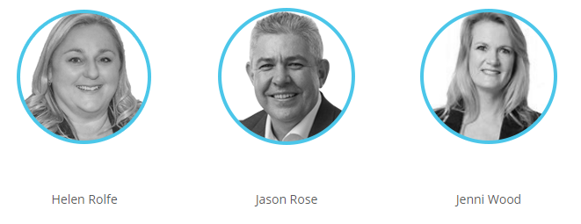
PART 1B INDUSTRY LEADERS | THE PM INFLUENCERS
THE JUDGES
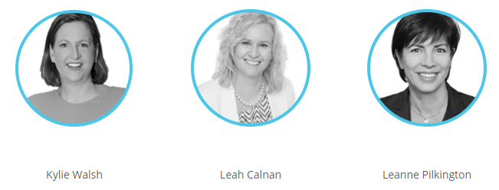
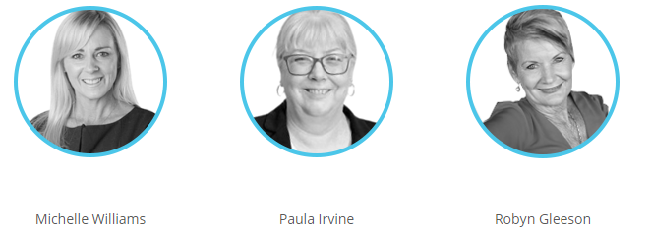

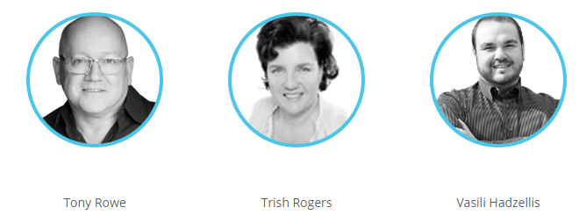

And respectfully to many more industry leaders, who are not currently part of the panel. If you would like to nominate an industry leader to be considered for the panel, please email awards@ppmgroup.com.au.

PART 2
SUBMISSION CATEGORY FORMS

PART 2 SUBMISSION FORM
Property Manager of the Year

This Award is open to all residential property managers.
Attach this form to the front of your award submission questions in a PDF file when emailing.

NOMINEE DETAILS
Enter details in the text fields below:
Nominee Name: Principal Name:
Agency Name:
Telephone: ( ) Mobile:
Contact Email: Website:
Agency Address: State: Postcode:
List any property management associated groups you are part of:

GENERAL INFORMATION & STATISTICS
Enter details in the text fields below:
- How long have you worked within the property management industry? years months
- How many 'residential' properties does your agency manage?
- How many 'residential' properties do you manage or oversee?
- Do you have support staff to assist you in managing these properties? If so, How many?
- What is your current arrears rate % (Report dated / / )
- What is your current vacancy rate % (Report dated / / )

AWARD QUESTIONS
Include the below questions at the top of each page of your submission when answering.
INCLUDE SUPPORTING DOCUMENTS WHERE POSSIBLE
1) Share your (personal and/or career) achievements, challenges, and highlights during the last 12 months as a timeline?
2) What do you feel that you do differently (from other property managers) in your day-to-day activities and processes of managing the property, landlord, and tenant?
3) What do you feel is the biggest challenge that property management team members and agencies face, and what can be done to overcome this challenge?
4) How did you manage the onset of COVID-19 in the way that you communicate with landlords and tenants, and what systems and processes were improved, changed, or modified as a result?
5) Why are you entering the Awards? What does winning mean to you, and how would you utilise the Award?

DECLARATION
I declare that the information I have provided is true and correct at the time of completion. I agree that I have read and understood the rules, terms, and conditions of the Awards. Unless otherwise indicated to the PPM Group, I give permission to use my details and photograph/s as appropriate in promoting the Awards, including placing my profile on the PPM Group's website, print material, or social media. Upon being selected as a finalist, I understand additional information or verification of information may be required. I agree that the Judges' decision is final.

Nominee Name: …………………………………………………………………… Date: ……. / ……… / ………

Nominee's Signature: ……………………………………….………………….………………...………….……….

Principal Name: …………………………………………………………………… Date: ……. / ……… / ………

Principal's Signature: ……………………………………………………………………………...………….……….
PART 2 SUBMISSION FORM
Business Development Manager of the Year

This Award is open to all business development managers or property managers who undertake the role.
Attach this form to the front of your award submission questions in a pdf file when emailing.

NOMINEE DETAILS
Enter details in the text fields below:
Nominee Name: Principal Name:
Agency Name:
Telephone: ( ) Mobile:
Contact Email: Website:
Agency Address: State: Postcode:
List any property management associated groups you are part of:

GENERAL INFORMATION & STATISTICS
Enter details in the text fields below:
- How long have you worked within the property management industry? years months
- How many 'residential' properties did you individually sign-up in the last 12 months?
(The number of properties signed-up does not determine the winner)

AWARD QUESTIONS
Include the below questions at the top of each page of your submission when answering.
INCLUDE SUPPORTING DOCUMENTS WHERE POSSIBLE
1) Share your (personal and career) achievements, challenges, and highlights during the last 12 months as a timeline? (Include testimonials or any additional BDM growth statistics)
- What do you feel that you do differently from other business development managers to win new business?
- What marketing ideas, strategies, and activities have you implemented during the last 12 months to increase your rent roll growth?
- How did you manage the onset of COVID-19 in the way that you communicate with landlords and tenants, and what systems and processes were improved, changed, or modified as a result?
5) Why are you entering the Awards? What does winning mean to you, and how would you utilise the Award?

DECLARATION
I declare that the information I have provided is true and correct at the time of completion. I agree that I have read and understood the rules, terms, and conditions of the Awards. Unless otherwise indicated to the PPM Group, I give permission to use my details and photograph/s as appropriate in promoting the Awards, including placing my profile on the PPM Group's website, print material, or social media. Upon being selected as a finalist, I understand additional information or verification of information may be required. I agree that the Judges' decision is final.

Nominee Name: …………………………………………………………………… Date: ……. / ……… / ………

Nominee's Signature: ……………………………………….………………….………………...………….……….

Principal Name: …………………………………………………………………… Date: …….. / ……… / ………

Principal's Signature: ……………………………………………………………………………...………….……….
PART 2 SUBMISSION FORM
Leasing Consultant of the Year

This Award is open to all leasing consultants or property managers who undertake the role.
Attach this form to the front of your award submission questions in a PDF file when emailing.

NOMINEE DETAILS
Enter details in the text fields below:
Nominee Name: Principal Name:
Agency Name:
Telephone: ( ) Mobile:
Contact Email: Website:
Agency Address: State: Postcode:
List any property management associated groups you are part of:

GENERAL INFORMATION & STATISTICS
Enter details in the text fields below:
- How long have you worked within the property management industry? years months

AWARD QUESTIONS
Include the below questions at the top of each page of your submission when answering.
INCLUDE SUPPORTING DOCUMENTS WHERE POSSIBLE

- Share your (personal and career) achievements, challenges, and highlights during the last 12 months as a timeline?
- Describe your marketing/advertising activities undertaken to rent properties in the last 12 months?
- (Provide three (3) examples of marketing/advertising copy, wording, images, or recordings in a link that you have written or produced to lease a property)
- What are your agency's points of difference when renting properties, and how do you manage the communication, feedback, and reporting process with landlords when a property is vacant?
(Include testimonials)
4) How did you manage the onset of COVID-19 in the way that you communicate with landlords and tenants, and what systems and processes were improved, changed, or modified as a result?
5) Why are you entering the Awards? What does winning mean to you, and how would you utilise the Award?

DECLARATION
I declare that the information I have provided is true and correct at the time of completion. I agree that I have read and understood the rules, terms, and conditions of the Awards. Unless otherwise indicated to the PPM Group, I give permission to use my details and photograph/s as appropriate in promoting the Awards, including placing my profile on the PPM Group's website, print material, or social media. Upon being selected as a finalist, I understand additional information or verification of information may be required. I agree that the Judges' decision is final.

Nominee Name: …………………………………………………………………… Date: ……. / ……… / ………

Nominee's Signature: ……………………………………….………………….………………...………….……….

Principal Name: …………………………………………………………………… Date: ……. / ……… / ………

Principal's Signature: ……………………………………………………………………………...………….……….
PART 2 SUBMISSION FORM
Property Management Support Team Member of the Year

This Award is open to all property management support team members, including receptionists, accounts staff, assistant property managers, and administrative staff.
Attach this form to the front of your award submission questions in a PDF file when emailing.

NOMINEE DETAILS
Enter details in the text fields below:
Nominee Name: Principal Name:
Agency Name:
Telephone: ( ) Mobile:
Contact Email: Website:
Agency Address: State: Postcode:
List any property management associated groups you are part of:

GENERAL INFORMATION & STATISTICS
Enter details in the text fields below:
- How long have you worked within the property management industry? years months

AWARD QUESTIONS
Include the below questions at the top of each page of your submission when answering.
INCLUDE SUPPORTING DOCUMENTS WHERE POSSIBLE

1) Share your (personal and/or career) achievements, challenges, and highlights during the last 12 months as a timeline?
2) Describe your position and role within the property management department and why you feel that you are a valued member of the team.
(Include general tenant/landlord testimonials as well as, a testimonial from your manager and/or principal)
3) What do you feel that you do differently (from other property management support team members) in your day-to-day activities and processes of assisting and managing the property, landlord, and tenant?
4) What are your career aspirations, and if you could change one aspect of property management, what would it be and why?
5) Why are you entering the Awards? What does winning mean to you, and how would you utilise the Award?

DECLARATION
I declare that the information I have provided is true and correct at the time of completion. I agree that I have read and understood the rules, terms, and conditions of the Awards. Unless otherwise indicated to the PPM Group, I give permission to use my details and photograph/s as appropriate in promoting the Awards, including placing my profile on the PPM Group's website, print material, or social media. Upon being selected as a finalist, I understand additional information or verification of information may be required. I agree that the Judges' decision is final.

Nominee Name: …………………………………………………………………… Date: ……. / ……… / ………

Nominee's Signature: ……………………………………….………………….………………...………….……….

Principal Name: …………………………………………………………………… Date: ……. / ……… / ………

Principal's Signature: ……………………………………………………………………………...………….……….
PART 2 SUBMISSION FORM
Property Management Client Service Award of the Year (Agency)

This Award is open to all agencies with a property management department.
Attach this form to the front of your award submission questions in a PDF file when emailing.

NOMINEE DETAILS
Enter details in the text fields below:
Best Contact Person: Principal Name:
Agency Name:
Telephone: ( ) Mobile:
Contact Email: Website:
Agency Address: State: Postcode:
List any property management associated groups you are part of:

AWARD QUESTIONS
Include the below questions at the top of each page of your submission when answering.
INCLUDE SUPPORTING DOCUMENTS WHERE POSSIBLE

- Share how you feel that your service delivery differs from your competitors and outline the client service strategies or initiatives you have embraced or implemented during the last 12 months. (Include testimonials)
- Provide two (2) examples of how you have delivered a superior level of service to your landlords and tenants during the last 12 months.
- What do you believe is the biggest challenge within the property management industry regarding service delivery, and how do you feel that this can be overcome?
- How does your agency manage, measure, and/or monitor your service delivery's effectiveness and satisfaction to your landlords and tenants?
- Why are you entering the Awards? What does winning mean to you, and how would you utilise the Award?

DECLARATION
I declare that the information I have provided is true and correct at the time of completion. I agree that I have read and understood the rules, terms, and conditions of the Awards. Unless otherwise indicated to the PPM Group, I give permission to use my details and photograph/s as appropriate in promoting the Awards, including placing my profile on the PPM Group's website, print material, or social media. Upon being selected as a finalist, I understand additional information or verification of information may be required. I agree that the Judges' decision is final.

Principal Name: …………………………………………………………………… Date: ……. / ……… / ………

Principal's Signature: ……………………………………………………………………………...………….……….
PART 2 SUBMISSION FORM
Property Management Agency of the Year | Small and Growing (Less than 400 residential properties)

This Award is open to all agencies with a property management department.
Attach this form to the front of your award submission questions in a PDF file when emailing.

NOMINEE DETAILS
Enter details in the text fields below:
Best Contact Person: Principal Name:
Agency Name:
Telephone: ( ) Mobile:
Contact Email: Website:
Agency Address: State: Postcode:
List any property management associated groups you are part of:

GENERAL INFORMATION
Enter details in the text fields below:
How many residential properties do you manage? How many PM team members do you employ?
How long has your agency been trading? ☐ years ☐ months

AWARD QUESTIONS
Include the below questions at the top of each page of your submission when answering.
INCLUDE SUPPORTING DOCUMENTS WHERE POSSIBLE

- Share your property management agency's achievements, challenges, and highlights during the last 12 months as a timeline?
- What are your agency's points of difference in your day-to-day processes for managing the property, landlord, and tenant?
- How did your property management agency manage the onset of COVID-19 in the way that you communicate with landlords and tenants, and what systems and processes were improved, changed, or modified as a result?
- What strategies has your agency embraced to improve growth, productivity, and profitability during the last 12 months?
- What do you believe to be the greatest challenge facing the property management industry, and how can this be improved or overcome?

DECLARATION:
I declare that the information I have provided is true and correct at the time of completion. I agree that I have read and understood the rules, terms, and conditions of the Awards. Unless otherwise indicated to the PPM Group, I give permission to use my details and photograph/s as appropriate in promoting the Awards, including placing my profile on the PPM Group's website, print material, or social media. Upon being selected as a finalist, I understand additional information or verification of information may be required. I agree that the Judges' decision is final.

Principal Name: …………………………………………………………………… Date: ……. / ……… / ………

Principal's Signature: ……………………………………………………………………………...………….……….

PART 2 SUBMISSION FORM
Property Management Agency of the Year | Large
(Greater than 400 residential properties)

This Award is open to all agencies with a property management department.
Attach this form to the front of your award submission questions in a PDF file when emailing.

NOMINEE DETAILS
Enter details in the text fields below:
Best Contact Person: Principal Name:
Agency Name:
Telephone: ( ) Mobile:
Contact Email: Website:
Agency Address: State: Postcode:
List any property management associated groups you are part of:

GENERAL INFORMATION
Enter details in the text fields below:
How many residential properties do you manage? How many PM team members do you employ?
How long has your agency been trading? ☐ years ☐ months

AWARD QUESTIONS
Include the below questions at the top of each page of your submission when answering.
INCLUDE SUPPORTING DOCUMENTS WHERE POSSIBLE

- Share your property management agency's achievements, challenges, and highlights during the last 12 months as a timeline?
- What are your agency's points of difference in your day-to-day processes for managing the property, landlord, and tenant?
- How did your property management agency manage the onset of COVID-19 in the way that you communicate with landlords and tenants, and what systems and processes were improved, changed, or modified as a result?
- What strategies has your agency embraced to improve growth, productivity, and profitability during the last 12 months?
- What do you believe to be the greatest challenge facing the property management industry, and how can this be improved or overcome?

DECLARATION:
I declare that the information I have provided is true and correct at the time of completion. I agree that I have read and understood the rules, terms, and conditions of the Awards. Unless otherwise indicated to the PPM Group, I give permission to use my details and photograph/s as appropriate in promoting the Awards, including placing my profile on the PPM Group's website, print material, or social media. Upon being selected as a finalist, I understand additional information or verification of information may be required. I agree that the Judges' decision is final.

Principal Name: …………………………………………………………………… Date: ……. / ……… / ………

Principal's Signature: ……………………………………………………………………………...………….……….

PART 2 SUBMISSION FORM
Property Management Digital Presence of the Year | Page 1
THE DIGITAL PRESENCE OF AN AGENCY'S SALES DEPARTMENT WILL NOT BE TAKEN INTO CONSIDERATION

This Award is open to all agencies with a property management department, a website, active social media, and a digital footprint.
Email this submission form once completed to awards@ppmgroup.com.au

NOMINEE DETAILS
Enter details in the text fields below:
Best Contact Person: Principal Name:
Agency Name:
Telephone: ( ) Mobile:
Contact Email: Website:
Agency Address: State: Postcode:
List any property management associated groups you are part of:

SOCIAL MEDIA PLATFORMS AND WEBISTE LINKS
Enter details in the text fields below:
Website:
Facebook:
LinkedIn:
Twitter: (If applicable)
Instagram: (If applicable)
Other: (If applicable)

Judges will assess the following criteria:

WEBSITE
- Branding theme, visual appearance, and user-friendliness to navigate.
- Unique features.
- Website placement ranking (SEO).
- Reviews.
- Mobile friendly.
- Methods adopted to encourage the collection of contact details.
- Content and information provided for landlords and tenants.
- Integration of social media.
- Display of rental properties.
- Frequency of blogs, articles, releases, and general information.
- The relevance of information.
- Errors, broken links, outdated content, typos, inconsistent styles or formatting, and load time.
- Images, virtual tours, and multimedia.
- Overall user experience.

SOCIAL MEDIA PLATFORMS
- Frequency of posts.
- The relevance of posts.
- Type of posts.
- Post interactions and responses.
- Use of hashtags.
PART 2 SUBMISSION FORM
Property Management Digital Presence of the Year | Page 2

DECLARATION
I declare that the information I have provided is true and correct at the time of completion. I agree that I have read and understood the rules, terms, and conditions of the Awards. Unless otherwise indicated to the PPM Group, I give permission to use my details and photograph/s as appropriate in promoting the Awards, including placing my profile on the PPM Group's website, print material, or social media. Upon being selected as a finalist, I understand additional information or verification of information may be required. I agree that the Judges' decision is final.

Principal Name: …………………………………………………………………… Date: ……. / ……… / ………

Principal's Signature: ……………………………………………………………………………...………….……….

